LACES BASEBALL ACADEMY
2022 ADVERTISING SPONSORSHIP FORM
LACES BASEBALL ACADEMY
20928 67TH DR NE
425-350-2232
LACESBASEBALL@HOTMAIL.COM
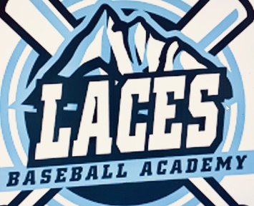
Potential Laces Sponsor –

Laces Baseball Academy is reaching out to local businesses in the local Snohomish County area to offer an opportunity to support a group of local youth baseball players by purchasing an advertising package for the Laces Baseball Academy 2022 season.

Our goal is to raise funds to help support our Scholarship players who may not have the means to participate without financial assistance. We are looking for sponsorships to help reach our goals in exchange for our support, patronage and advertising! Below are the Advertising Packages that we are offering for the 2022 season. All advertisements will run for one annual year starting January 1st 2022 ending December 31st 2022.

HOMERUN PACKAGE:
Website Advertisement – Lacesbaseballacademy.com – Launching Jan 1 2022
Facebook Advertisement – Laces Baseball Academy
Twitter Advertisement - @Laces_Wa
Laces Digital Program Advertisement (Emailed to all Laces Tournament Teams and Families)
Cost - $500

TRIPLE PACKAGE:
Website Advertisement - Lacesbaseballacademy.com – Launching Jan 1 2022
Facebook Advertisement – Laces Baseball Academy
Twitter Advertisement - @Laces_Wa
Cost - $400

DOUBLE PACKAGE:
Website Advertisement - Lacesbaseballacademy.com – Launching Jan 1 2022
Facebook Advertisement – Laces Baseball Academy
Cost - $300

SINGLE PACKAGE:
Website Advertisement - Lacesbaseballacademy.com – Launching Jan 1 2022
Cost - $200

If you have interest in supporting the Academy by sponsoring our Laces scholarship players please email us at lacesbaseball@hotmail.com and we will send out your Sponsorship Registration Information. We thank you in advance for any consideration in helping us reach our goals!

Levi Lacey and the Laces Baseball Academy Staff

